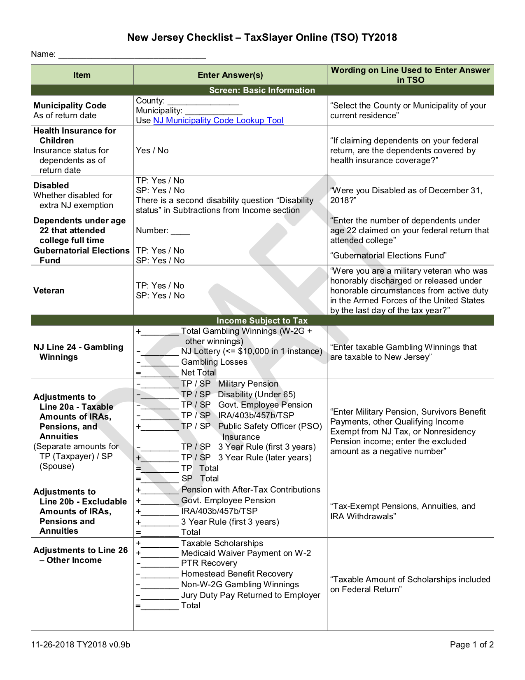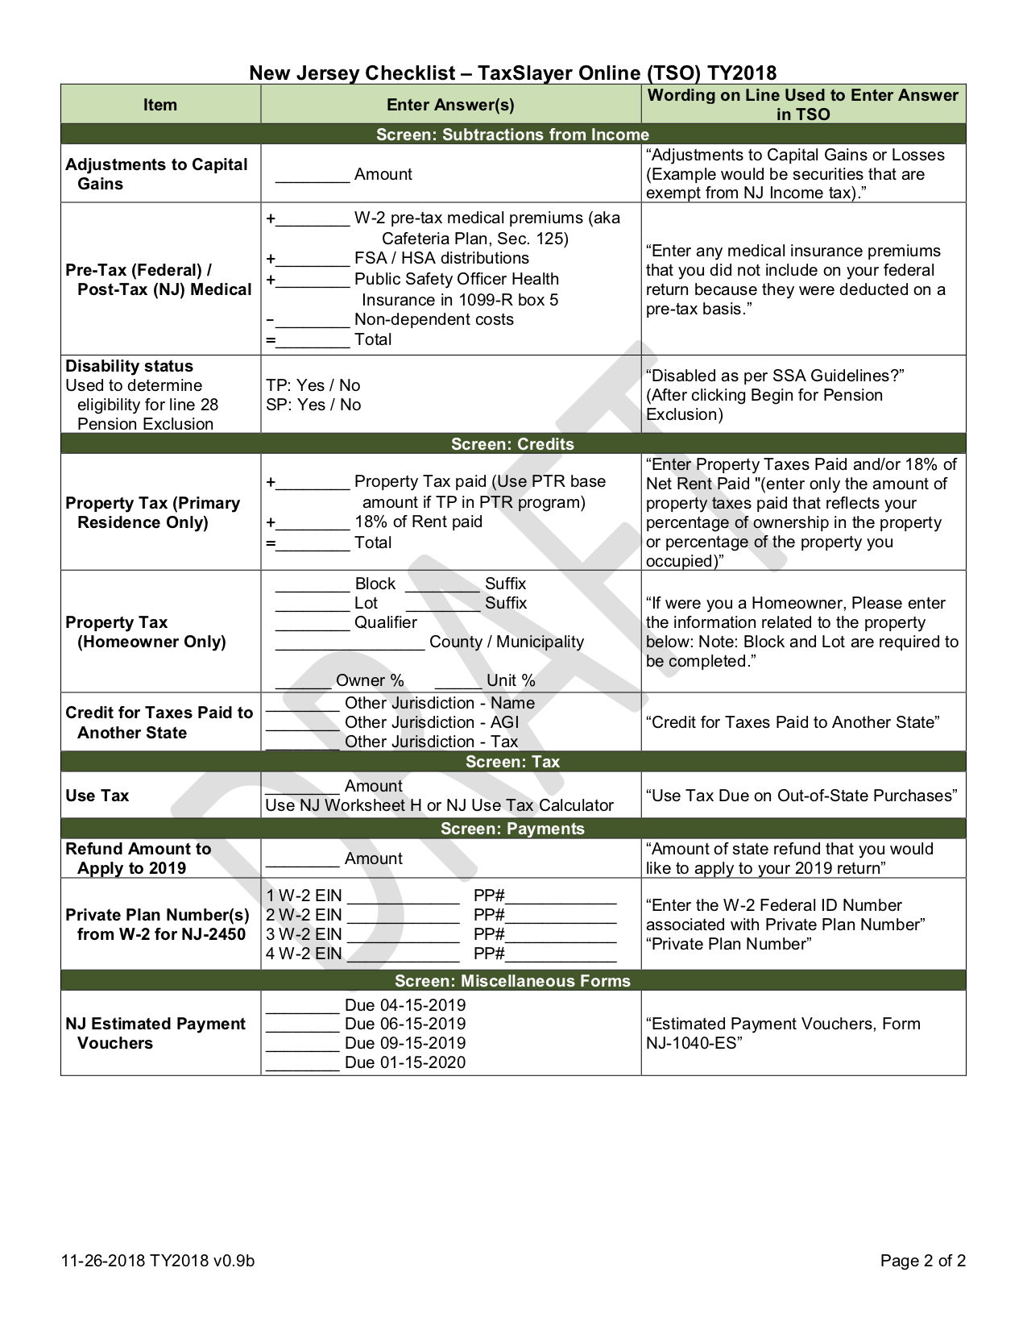

-400

400

619

-12,000

12,000

10,000

10,000

TP is Vet, but does not qualify

Hale NJ Checklist v0.9b

See Scratchpads

Use Zero

0

619

See Annuity Calc

Hale

Somerset

Bedminster Township

Hale NJ Checklist v0.9b

00002

50001

14

7,385

7,385